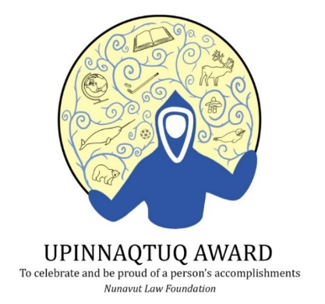
Press Release
For Immediate Release

Nunavut Law Foundation Proudly Presents
the 2025 Upinnaqtuq Award Winners

November 2025 – The Nunavut Law Foundation is thrilled to announce the winners of the 2025 Upinnaqtuq Awards, which celebrate the extraordinary achievements and leadership of youth across Nunavut. The Upinnaqtuq Awards, established in honor of Justice Beverley Browne’s enduring legacy, are a symbol of the bright future that these young individuals represent.

Each year, these awards recognize youth who not only exhibit outstanding leadership and commitment to their communities but also inspire those around them through resilience and positive change. The 2025 recipients exemplify these values, demonstrating that leadership knows no age, and that the contributions of young people are vital to the growth and strength of our communities.

The 2025 Upinnaqtuq Award recipients are:

Kayalaaq Leishman Brocklebank – Chesterfield Inlet
Dylan Kayotak – Iglulik
Azriel Tagnigou-Petnkeu – Iqaluit
Kylie Ipeelie-Dunphy - Iqaluit
Jazmine Akeeagoak – Iqaluit

Celebrating Leadership and Community Impact
The Upinnaqtuq Awards recognize a broad spectrum of contributions, from leadership in academics and sports to community service and cultural preservation. These youth have shown exceptional dedication, whether through mentoring their peers, preserving Inuit traditions, excelling in athletics, or leading community initiatives. Their stories of perseverance and achievement are an inspiration to all.

"These young leaders have shown us the power of dedication and community spirit," said Sarah Arngna'naaq, Chair of the Nunavut Law Foundation. "Their contributions are a beacon of hope and a testament to the strength that comes from supporting one another. It is with great pride that we celebrate their achievements."

A Legacy of Inspiration
The Upinnaqtuq Awards, meaning 'pride and celebration' in Inuktitut, were created to honor the vision of Justice Beverley Browne, who believed deeply in the potential of Nunavut’s youth. This year’s awardees continue this legacy by embodying the spirit of service, leadership, and community engagement that Justice Browne championed.

Each recipient will receive a certificate and a gift in recognition of their accomplishments. The Nunavut Law Foundation extends heartfelt congratulations to the winners and expresses deep gratitude to the families, educators, and community members who support these remarkable young leaders. The Foundation also thanks all who participated in the nomination process, helping to shine a light on the vital contributions of Nunavut's youth.

For more information about the Upinnaqtuq Awards and the Nunavut Law Foundation, please visit www.nunavutlawfoundation.ca or contact Shawna Allooloo at administrator@nulf.ca.

-30-

About the Nunavut Law Foundation:
The Nunavut Law Foundation is a non-profit organization funded by the Law Society of Nunavut, representing all lawyers practicing law in the territory. Its mission is to support and promote the knowledge of law and the administration of justice in Nunavut.

Contact:
Shawna Allooloo, Administrator

administrator@nulf.ca • P.O. Box 69, Iqaluit NU, X0A 0H0

