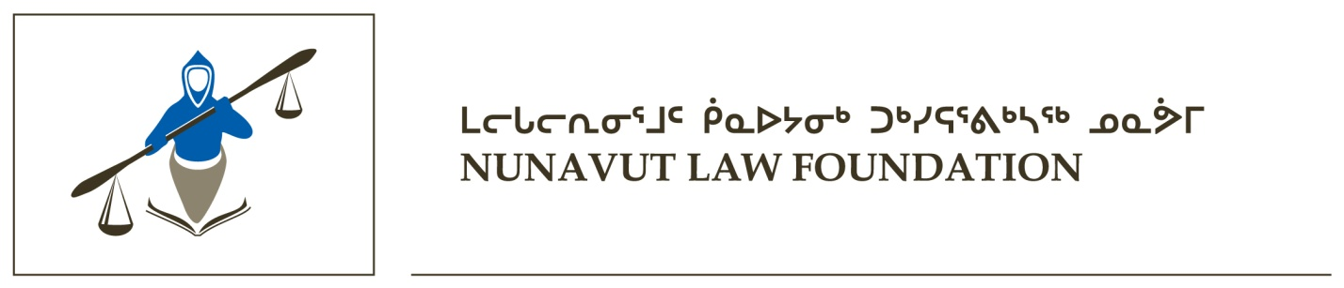

Official Appointment to Nunavut Law Foundation

The Nunavut Law Foundation is proud to announce the official appointment of Mandy Sammurtok as the Chairperson of the Nunavut Law Foundation. This is the first time in the Foundation’s history that an Inuk is appointed as Chairperson.

Ms. Sammurtok is originally from Chesterfield Inlet, Nunavut. She received her law degree from the University of Manitoba in 2007 and was called to the bar in Manitoba in 2008, after articling with Legal Aid Manitoba. Ms. Sammurtok has been practising criminal law at Maliiganik Tukiisiniakvik in Iqaluit, Nunavut, ever since passing the Nunavut bar in 2009.

Mandy Sammurtok will be appointed for a two-year term effective February 2013. The other members are Cindy Kieu, a lawyer with the Government of Nunavut and Sandra Omik, a lawyer with the Nunavut Tunngavik Incorporated.

The Foundation is a non-profit foundation providing grants and funding throughout Nunavut that benefit Nunavummiut in the following areas: legal education, community justice, legal research and law reform. The monies received by the Foundation come from annual levies collected by the Law Society of Nunavut from all lawyers who apply for a license to practice in Nunavut.

The Foundation also provides the Upinnaqtuq Award in honour of Justice Beverly Browne, to Nunavut high school students and the Lucien Ukaliannuk Studies in Law award to law students or students engaged in the justice-related studies.

The Foundation’s board of directors consists of four lawyers appointed by Law Society of Nunavut to serve as volunteer board of directors and a volunteer lay member appointed by the Commissioner of Nunavut.

Contact for inquiries or questions:

Administrator of the Nunavut Law Foundation
P.O. Box 69
Iqaluit, NU
X0A 0H0

email: student@lawsociety.nu.ca

phone: (867) 979-2330

fax: (867) 979-2333

